**Language and style in ‘Shrinking Sinking Land’**

**There are two key motifs in this narrative. Write down quotes for these two motifs and explain what the two motifs symbolize.**



****Umbrella: this is a motif of survival in the short story. It is a potential weapon, a shield, a raft. “There were three main ways an umbrella could save your life.” This is typical of the conventions of cli-fi as survival is often a key theme.****

[**https://live.staticflickr.com/8508/8498936235_f5c910f357_b.jpg**](https://live.staticflickr.com/8508/8498936235_f5c910f357_b.jpg)

[**https://content.api.news/v3/images/bin/4ee3cfecb44eeb037b52ef48746af046**](https://content.api.news/v3/images/bin/4ee3cfecb44eeb037b52ef48746af046)

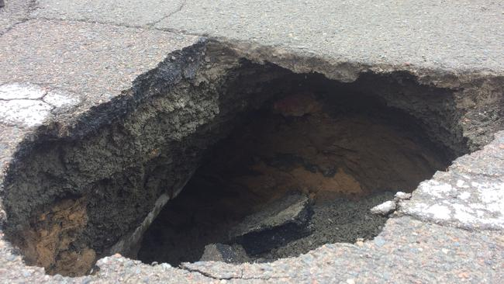****The sinkhole is another motif in the short story, symbolizing hopelessness, giving up and being stuck. Shell chooses to remain in the sinkhole, not being able to face the reality of climate disaster and a changed world. Flea tries to get Shell out of the sinkhole but Shell chooses to remain stuck. “yawning crater…she peered down into the sinkhole’s shadows, feeling its mouth gaping to swallow her whole.”****

**Identify the language feature used in the following examples and explain what the examples show us:**

1. **“freak weather conditions” “stream of floodwater” “city swamps sloshing around”: **descriptive language – description of the landscape changed by the climate disaster. Sibilance (repetition of s or sh sounds) mimics the sound of water which immerses the reader in this flooded landscape. Check you identified the language feature correctly and explained what it shows correctly.****

**(These examples are NOT FIGURATIVE LANGUAGE! The difference between descriptive and figurative language is that descriptive language is literal – describing things as they actually are; while figurative language is describing things in an imagined way to help convey an idea. Example: she has yellow, stiff hair is descriptive as it describes the girl’s hair as it actually is. She has straw hair like a scarecrow is figurative – the girl doesn’t actually have straw for hair.)**

1. **“poor drowned Liverpool” “yawning crater” “feeling its mouth gaping to swallow her whole” **Personification – this is a type of figurative language so the meaning. The land is give human like qualities. The first example likens the city to a drowned human, creating a sense of the city feeling helpless and overpowered by the storming floodwaters, highlighting how climate disaster has made nature far more powerful than even the biggest human cities. The second and third examples make the sinkhole seem like a monster with a huge mouth that almost eats people. This personification again makes nature seem far more powerful than human beings.** **Check you identified the language feature correctly and explained what it shows correctly.****
2. **“a lonely little spider of a woman flushed down the earth’s toilet bowl” “Before the toxic waste buried down there brings you out in scales” “it looked like her dirty blonde hair was slowly turning to seaweed” “use it to fish her mother out” “you’re just a silly mare that’s stuck at the bottom of a hole” “feeding their mum like a baby bird” **Zoomorphism – another type of figurative language, this is the opposite of personification. People are given animal or nature like qualities. In these examples of zoomorphism, creates a kind of reverse Darwinism where the characters, particularly Shelly, seem to be reverting back to animal states. This de-evolution creates the idea that possible the time of human species dominance may be at an end. It suggests that nature is more powerful than humankind and that, unless we adapt and change, we may not be able to overcome climate disaster. Check you identified the language feature correctly and explained what it shows correctly.****
3. **“it’s like going back into the womb. Like being safe inside your mum’s tum” “ peaceful little womb tomb” **These examples are combination of simile and metaphor, types of figurative language. These examples have a similar effect as the zoomorphism, creating a regression in time where the adult Shelly longs for the lost innocence and safety of infancy. This draws on the typical motif of birth that occurs in many cli-fi narratives, but uses that motif and reverses it creating images of birth in reverse. It symbolizes hopelessness and Shelly’s inability to cope with the changed world. Check you identified the language feature correctly and explained what it shows correctly.****